**Class variables & Instance variables**

Class variables are shared by all instances

Instance variables are unique to each instance

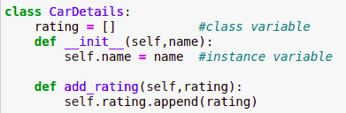

While dealing with mutable objects such as lists, if we define the list as a class variable, then adding elements to that list may apply to all instances or to all objects for which class is assigned.

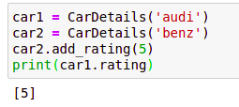

Adding an element to the rating of object car2 has shown impact on the rating of object car1.

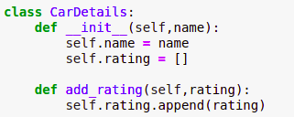

For the above code, if we add an element to the car2 rating list it doesn't show any impact on the rating of object car1